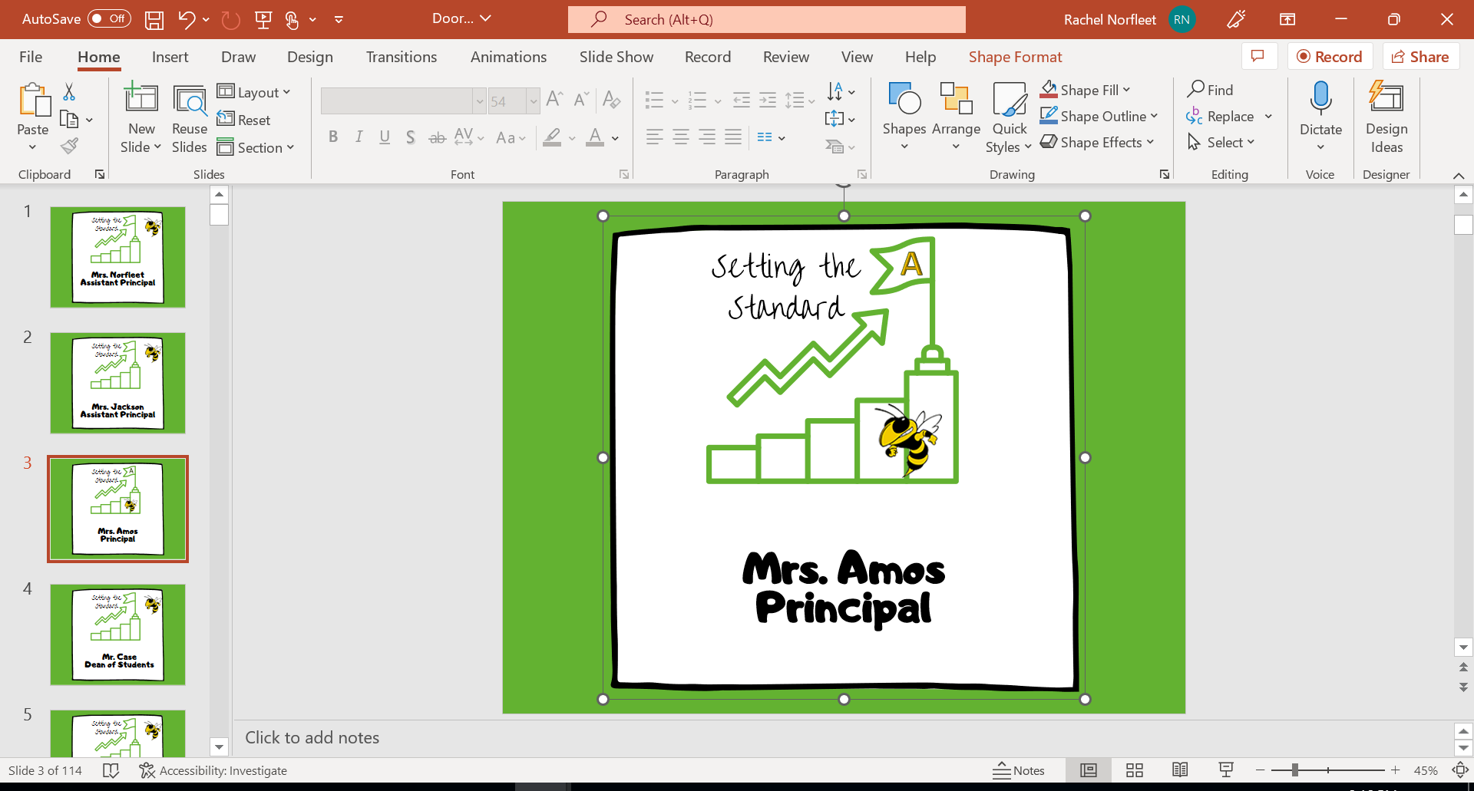
Full Day Schedule
1st period – 9:00-9:50
2nd period – 9:54-10:42
3rd period – 10:46-11:34
4th period – 11:38-1:10
1st lunch – 11:35-12:05
2nd lunch – 12:07-12:37
3rd lunch – 12:40-1:10
5th period – 1:14-2:02
6th period – 2:06-2:54
7th period – 2:57-3:45

